ABC’s of Grade 3

is for...
Attendance-much of our learning will take place together in class. We do many hands-on activities, centers and group work. It is very difficult to recreate these activities at home. Please ensure your child attends each day except in cases of illness, emergency, or if you are lucky enough to be far away at a tropical destination.
Agendas-student agendas (planner) will be sent home each day and should stay in their STAR binder. Please read and sign the agenda and send the binder to school every day.
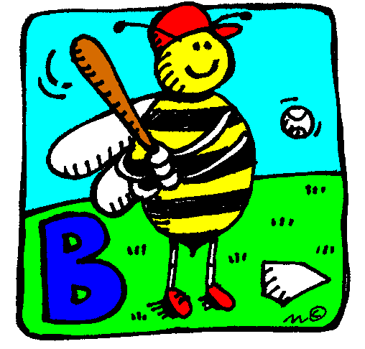 is for...
Book orders-Scholastic book orders will be sent home about once a month. This is a great way to purchase books inexpensively, while helping our class earn points towards other items! I would ask that you send cheques only as it is much easier to make payments.
Birthdays-As per new guidelines, birthday invitations will no longer be allowed to be passed out in school. Birthdays will be celebrated each month with a celebration in the all purpose room. Ms. Raspanti will send invitations to the event each month to those whom it applies. I do plan on honouring your child’s birthday in class as close to the day as possible. We will celebrate summer birthdays during the last few weeks of school. If you plan on sending in a snack (completely optional), please make sure it is a healthy one or

maybe not a food item at all (something like pencils, silly bands etc.).

Back to School Night: I look forward to meeting you at back to school night on September 23. Additional information will be posted in the virtual backpack about the time and other pertinent details.
is for...
Communication-please feel free to contact me by e-mail or call me at school with questions or concerns you may have. You can also send a note in your child’s agenda. fichnerj@middltetownk12.org
is for...
Dismissal-School ends at 3:00. Please send a note or call the school if your child needs to be dismissed at a different time.
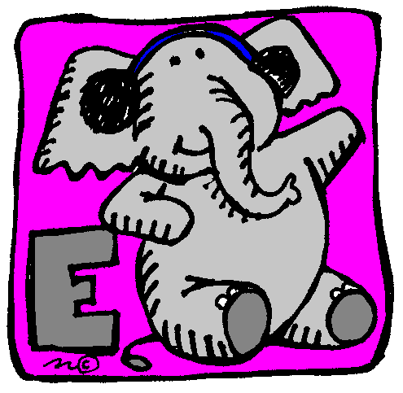 is for...
Emergencies-please make sure we have the correct emergency information on file for your child.
is for...
Field Trips-We have scheduled field trips throughout the year. As they come up, permission and volunteer letters will be sent home with all of the information you will require.
is for...
Grading Scale-assessment is based on a 5-point system in Middletown. (1-Not meeting the standard, 2-Progressing toward the standard, 2+ Progressing well toward the standard 3-Meets the standard, and E-Exceeds the standard).
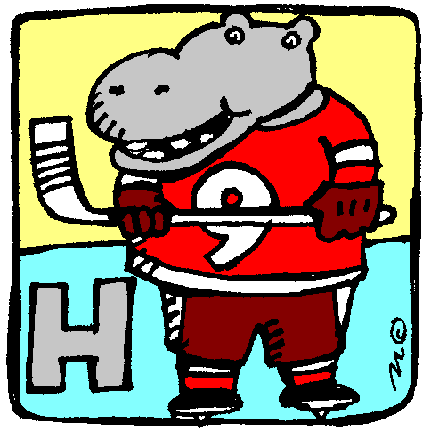is for...
Homework-Your child will have nightly home reading (15 min EVERY night including Friday), word practice homework (10 words- M-TH) and a math practice worksheet (M-TH). It is expected that all homework is completed each night. Students re responsible for their own work and remembering to bring in their assignments on time.
is for...
Important Information-Any notes home, finished work, or other important information will be sent home in their homework folder inside their STAR binder. Any important information you need to communicate should go in the agenda/planner or homework folder. Students are responsible for handing in notes and homework themselves. I do not check individual folders or planners.
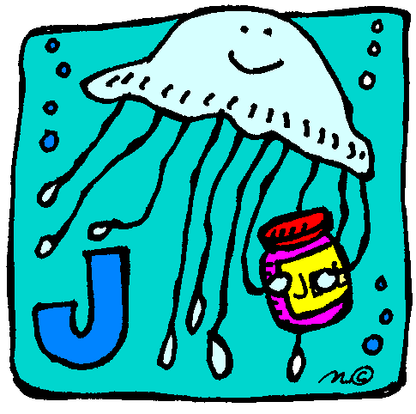is for...
Journals-Your child will use a writing journal throughout the school year, during writer’s workshop. We will work hard to become great writers!
is for...
Kindness- My goal for our class is to create a community of learners where students show kindness and respect. We will work each day to keep our room a safe place where all students feel comfortable.

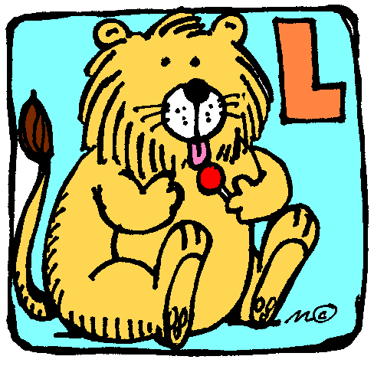is for...
Library-Once a week, we will visit the library. Please ensure your child’s books are returned each week, so that others may enjoy them as much as they have.
Lunch-lunch begins at 11:50 and ends at 12:20. Please make sure your child knows if they should be ordering lunch for that day or if they brought a lunch from home. Information regarding lunch pricing etc. can be found on the district website.
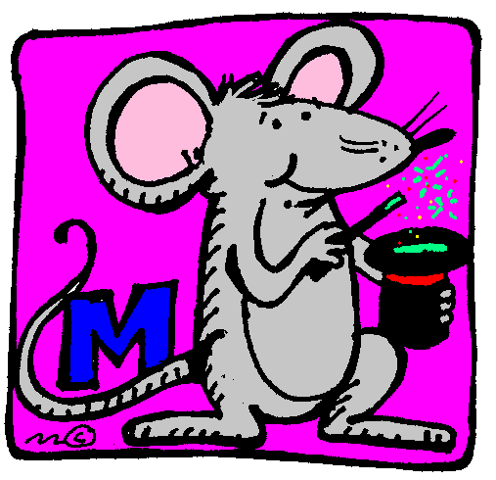is for...
Management-I have sent a separate sheet home with our classroom management information.
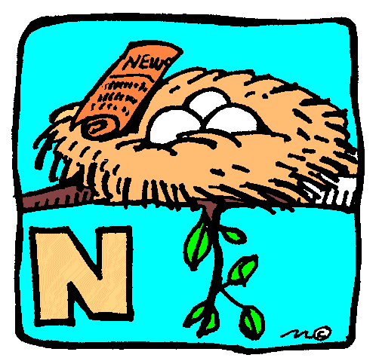is for...
Nut Aware-We are peanut and nut aware in our classroom. Please try to refrain from sending snacks and lunches with peanuts and nuts to school. Let’s all take part in making our classroom safe for everyone. Nut Aware snacks include: fresh fruit and vegetables, fruit to go, raisins, cheese strings, pudding, fruit cups, goldfish crackers, bear paws, etc.
is for...
Organization-I really encourage independence and organizational skills in Grade 3. Please support your child in their ability to stay organized by remembering their binder and home reading every day, as well as their library books once a week.
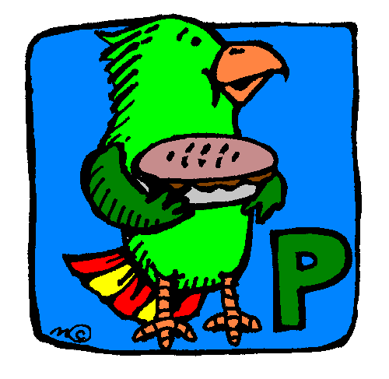is for...
Parties-We will have 4 parties this year (2 of our choice, 1 End of the year party, and 1 themed party (a party to go along with something we are studying in school). Parties will be organized with the parent class captain. Notes will be sent home with more information as those times arise.
Parent/Teacher Conferences-We will meet to discuss your child’s progress in early December. Information and sign-up dates and times will be sent home in a separate note as those times arise.
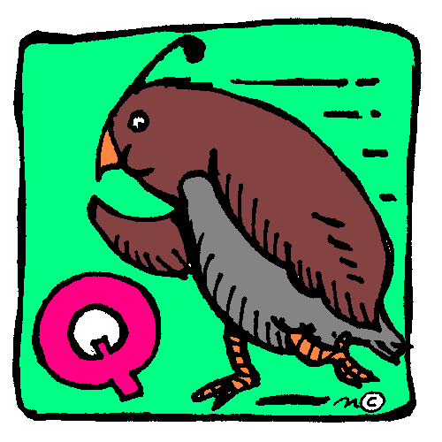is for...
Questions-remember to always check your child’s comprehension during home reading time to ensure they understand what they are reading.
If at any time you have questions about anything going on in the classroom, do not hesitate to contact me. I will be glad to talk with you!

is for...
Reading-Beginning the second week of school, your child will bring home information regarding nightly home reading. Students are expected to read for a minimum of 15 minutes per night as part of their third grade homework. We will be participating in the schools reading challenge each month so don’t forget to remind your child to hand in their reading log on time!
**The district has adopted a new reading program this year and I can’t wait to tell you all about it at back to school night!
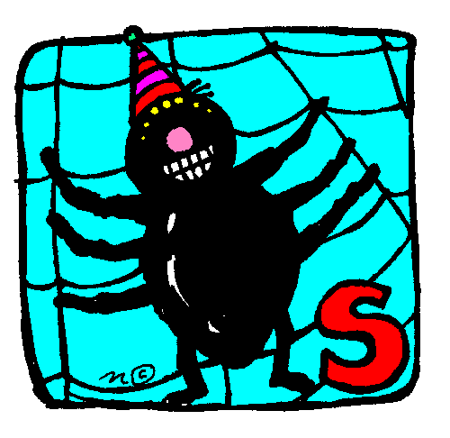is for...
Snack; We will have a working snack each day around 10:15. Please try to follow the districts’ nutritional guidelines for snack. The guidelines can be found on the district website.
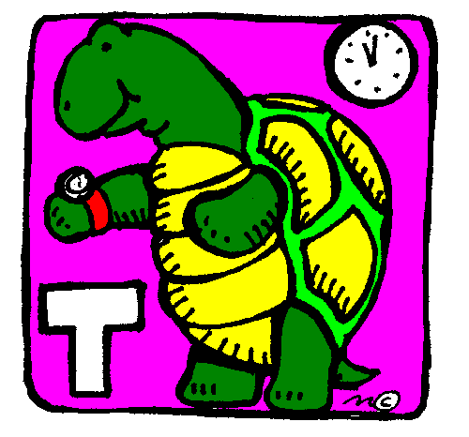is for...
Tardiness-classes begin at 9:00 a.m. Arriving after this time causes students to lose instructional time and they are required to go to the office to get a late slip.
Toys-Unless we are having a special day or your child has earned a coupon to bring a stuffed animal from home, toys are not permitted during class time. Items, which are not on the school supply list, can distract your child from learning and little hearts are broken as toys are often lost at school or accidentally damaged.
is for...
Units-we cover many curriculum units throughout the year. Third grade is a fun but challenging year. I am looking forward to the topics we will discuss and the many concepts we will cover this year. Please do not hesitate to contact me with questions you may have regarding our current units of study.
is for...
Volunteers-We love volunteers! You can volunteer in class or work on things for class at home. We will also have volunteers to come with us on field trips. Please write a note in your child’s agenda if you would like to help out and I can let you know what we may need. Volunteers for field trips will be chosen when information about the trips are sent home later in the year.

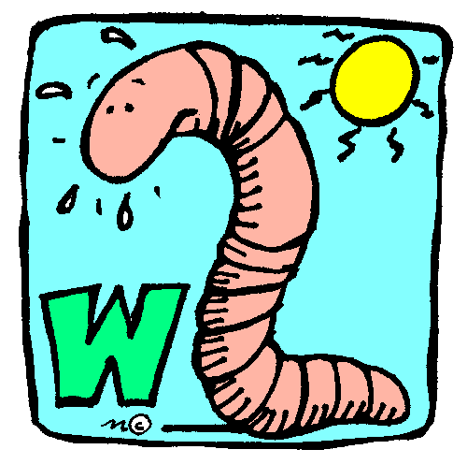is for...
Water-your child may bring a water bottle to keep in their backpack. Please ensure it is labelled with your child’s name. I do not restrict students from going to their backpack to get a drink.
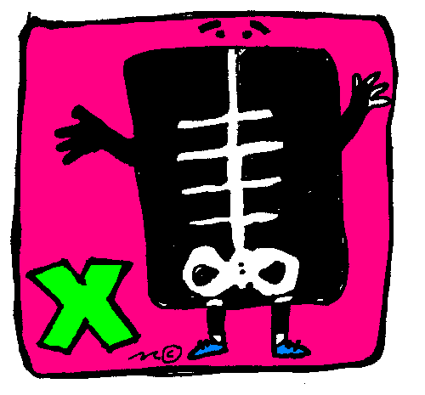
I am eXcited to work with you and your
child this year! Make sure he/she gets
plenty of zzzzz’s each night as we have exciting days planned for this year.

Your ideas and suggestions are welcome. Please let me know if there is anything I have missed or you would have liked to see included in The ABCs of Grade 3.

I look forward to a wonderful year with your child and with you!
~Mrs. Fichner

